Linkedin Challenge:Insights from a global retail store
Problem Statement
An online retail business wants to better understand its sales performance in order to optimize product strategy and customer engagement. Using the Online Retail dataset, which contains over 500,000 transaction-level records, the objective of this analysis is to identify bestselling products and determine when customers are most likely to make purchases. The dataset includes key attributes such as invoice details, product descriptions, quantities, prices, transaction timestamps, customer identifiers, and country information.
To ensure manageable performance while retaining analytical value, the analysis focuses on transactions from the United Kingdom only. The data contains known quality issues, including returns, negative quantities, and missing customer identifiers, which reflect real-world business complexity and are documented rather than removed entirely.
By cleaning the data, calculating total sales per transaction, and analyzing sales trends by product, hour, and day of the week, this project aims to generate actionable insights. These insights can support data-driven decisions related to inventory planning, marketing timing, and revenue optimization.
Insights gathered from the dataset
Top 10 items by revenue and quantity
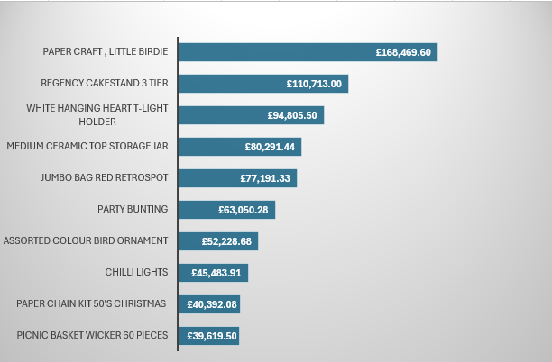
Revenue is heavily concentrated in the top three products, with Paper Craft, Little Birdie alone generating more revenue than the bottom four products combined. This highlights a strong customer preference and its critical importance to overall sales.These top-performing festive items should be prioritized for inventory planning to avoid stockouts. Targeted marketing during festive periods and cross-selling with complementary products can further increase average order value and maximize revenue.

Top 10 items by Quantity sold
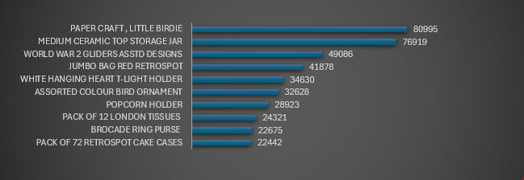
As we can see in the graph above the top 2 items generate as much revenue like the bottom 5, which means that there is disproportionate distribution of sales. This pattern indicates that volume sales are driven by affrdability and repeat buying behavior, rather than premium pricing. The consistent presence of giftable and decorative items also highlights the importance of impulse and occasion-based purchasing. To capitalize on this behavior, these high-volume low cost products should be kept consistently in stock and positioned as core inventory items. Bundling them with higher-margin products or offering multi-buy promotions can increase average order value.
Shopping time analysis
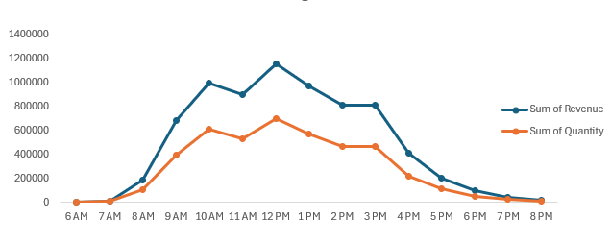
The chart shows a strong correlation between revenue and quantity sold, with both metrics rising and falling in tandem throughout the day. Customer activity begins to increase after 6 AM, accelerates steadily from around 8 AM, and reaches its peak during the 10 AM to 2 PM window. After 3 PM, both revenue and sales volume decline consistently, reaching their lowest levels by 8 PM.The key takeaway is that the 10 AM to 2 PM period represents the core shopping window. Promotional campaigns, discounts, and targeted offers should be scheduled during this timeframe to maximize customer engagement and conversions. Additionally, customer support teams should be most active during peak hours to handle increased demand, and website or app performance should be optimized to ensure a smooth customer experience when traffic is highest.

Revenue Distribution by day of the week
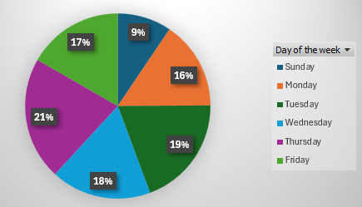
We can infer from the plot above that Saturday is a non-working day for the store for reasons best known to them. Revenue is the least on Sunday and the most on Thursday. Revenue peaks mostly during the midweek Thursday and Wednesday which means most purchases take place during midweek. Hence Midweek is most critical for business, hence major promotions, product launches, and inventory replenishment should be scheduled ahead of these peak days. To address weaker Sunday performance, targeted incentives such as limited-time discounts or reminder campaigns could be introduced to stimulate demand. Additionally, staffing, customer support, and system capacity should be aligned with midweek peaks to ensure smooth operations and capture the highest possible revenue.
Running Total Analysis
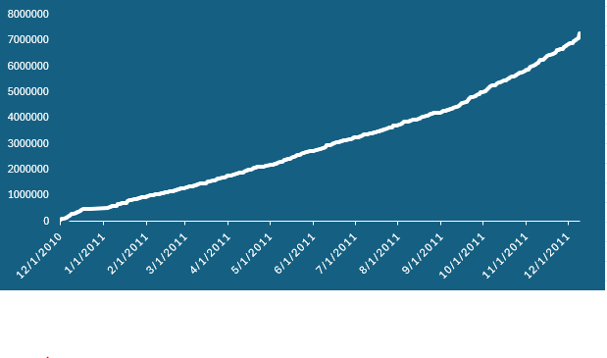
The running total shows a steady increase in revenue throughout the year, indicating consistent business growth rather than reliance on short-term spikes. Revenue grows gradually in the early months and accelerates in the second half of the year, especially toward the end, suggesting higher demand during festive or peak seasons.The absence of sharp drops indicates stable operations and sustained customer demand. The steeper growth toward year-end highlights the importance of seasonality in driving sales.

Revenue growth trend
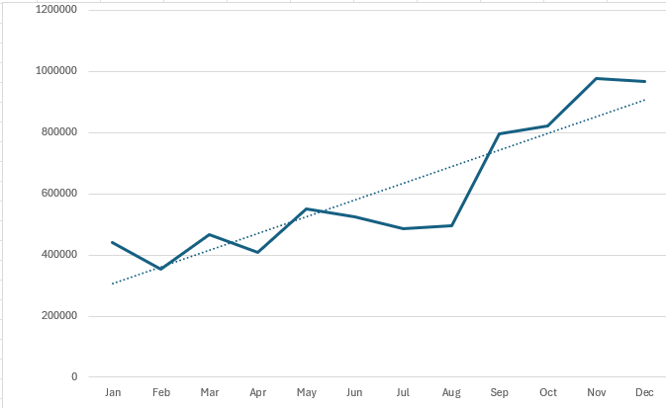
The chart shows that revenue generally increases throughout the year, indicating steady business growth. While there are some small ups and downs in the early months, the overall direction remains positive. From around August onward, revenue rises sharply, showing a strong increase in customer demand during the second half of the year. The highest sales occur toward the end of the year, suggesting a clear seasonal or festive impact. Even though growth slows slightly in December, revenue remains at a high level. Overall, the business is growing consistently, with most revenue being generated in the later months
Additional Insights
- The average basket size is 255 items, indicating strong bulk-purchasing behavior among customers. This presents an opportunity to further encourage high-volume orders through tiered discounts, volume-based pricing, and loyalty programs.
- Customer ID 17422 emerges as the most valuable customer, with the highest quantity per order. Retention strategies such as personalized discounts, exclusive offers, and priority engagement should be implemented to sustain and grow this relationship.
- Out of 3,833 products, 1,023 are evergreen, meaning they sell consistently every month in the UK market. While these form a stable sales base, slower-moving products can be strategically cross-sold alongside popular items to improve their visibility and performance.
- The Pareto principle is clearly evident: approximately 21% of products (790 items) contribute to 80% of total revenue. Ensuring consistent availability and focused promotion of these high-impact products is critical to revenue stability.
- Approximately 25% of invoices generate revenue above the average order value, indicating the presence of high-value transactions. Targeting and replicating the behaviors behind these larger orders can help lift overall revenue performance.

